POPULAR GREEK MUSICIANS IN POLAND

Greek songs fascinate foreigners with their unique mood, sound, the way they can capture listeners’ emotions. The impetuousness of Greek music and dance caused that Greek bands have been very popular throughout Poland for many years. Greek artistic agencies and Greek music bands create exceptionally variable and colourful artistic programmes presenting Greek music, from the ancient folk songs to temporary concert and disco hits.

ELENI TZOKA (neé Milopoulu) (born April 27, 1956 in Bielawa, Poland) is a Polish female singer of Greek descent.
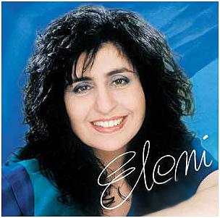
Tzoka started her professional career in 1975 when she joined Prometheus, a newly founded music band that was mainly active in Sopot in northern Poland. On July 20 of the same year, she debuted at a concert in Gdańsk.

Eleni, as she is commonly referred to in Poland, released her first solo album, Ty jak niebo, ja – jak obłok, in 1980 (although she had recorded an LP album with Prometheus earlier) titled Po słonecznej stronie życia ("On the sunny side of life'", 1977). After the release of her solo album, she became popular. She began giving concerts all over Poland as well as abroad. Among many other countries, she visited Australia; France; Sweden; Canada; and the United States, where she sang for the Polish diaspora.

Prometheus, the band Tzoka has belonged to since 1975, typically played traditional Greek music. Their shows included Greek dances, which were very popular among the audience. Tzoka's music is characterized by optimism and melodiousness.

NIKOS RUSKETOS - born 12 September 1958 in Zgorzelec. He comes from a family of Greek immigrants, who left Greece because of political issues.
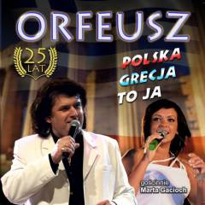
Nikos has Polish and Greek citizenship.
When he was 14, he and his Greek friends founded a music band - Flowers of Acropolis. They were giving concerts for a few years, representing the town of Zgorzelec.
In 1979 he went to Greece with his mother and brothers, where he sang and danced in local music bands. He came back to Poland after six months.
In 1982 he and other musicians created the band “Orpheus” (Orfeusz), existing until the present day.

He is a friend of Demis Roussous, and his manager in Poland. They have performed together at 11 concerts so far.

Nikos organises Greek Days in many towns and cities in Poland, with the participation of many excellent artists from Greece.

