GREEK SONGS

Greek Lullabies

1st song
Να μου το πάρεις ύπνε μου,  τρεις βίγλες θα του βάλω,  τρεις βίγλες, τρεις βιγλάτορες,  και οι τρεις αντρειωμένοι.  Βάζω τον ήλιο στα βουνά,  τον αϊτό στους κάμπους,  τον κυρ-Βοριά τον δροσερό,  ανάμεσα πελάγου.  Ο ήλιος εβασίλεψεν,  ο αϊτός αποκοιμήθει,  κι ο κυρ-Βοριάς ο δροσερός  στης μάνας του πηγαίνει.  "Γιε μ', πού σουν χτες,  πού  σουν προχτές,  πού σουν την άλλη νύχτα;  Μήνα με τ' άστρι μάλωνες,  μήνα με το φεγγάρι,  μήνα με τον Αυγερινό  που 'μασταν αγαπημένοι;"  "Μήτε με τ' άστρι μάλωνα,  μήτε με το φεγγάρι,  μήτε με τον Αυγερινό  που 'μαστ' αγαπημένοι.  Χρυσόν υγιόν εβίγλιζα  στην αργυρή του κούνια.". | Take my baby Morpheus  I will set three observatories to protect him,  three observatories, three observators,  and three brave men.  I place the sun to the mountains,  the eagle to the hills,  the refreshing Mr.North,  among the sea.  The sun has gone  and the eagle has slept.  The Mr. North the refreshing,  is going to his mother.  “My son, where were you yesterday,  where were you the day before yesterday,  where were you the other night?  Maybe with the star you were dueling,  maybe with the moon,  maybe with the morning star,  that we get on well.”  “Neither with the star I was dueling,  neither with the moon,  neither with the morning star,  that we get on well”.  Gold son I was observing  on his silver crudle.

2nd song
Κοιμήσου αστρί, κοιμήσου αυγή,  κοιμήσου νιο φεγγάρι  κοιμήσου, που να σε χαρεί  ο νιος που θα σε πάρει.  Κοιμήσου και παράγγειλα  στην Πόλη τα χρυσά σου,  στη Βενετιάτα ρούχα σου  και τα διαματικά σου. | Sleep star, sleep sun  sleep new moon,  sleep and the son will marry you  will be proud of you,  Sleep and I ordered  in Istanbul your gold jewelleries,  in Venice your clothes  and your diamonds.
Greek wedding songs

A wedding is taking place today
Σήμερα γά-, σήμερα γάμος γίνεται  Σ ωραίο περιβόλι σ' ωραίο περιβόλι ] 2x  Σήμερα απο-, σήμερα αποχωρίζεται  Η μάνα από την κόρη, η μάνα από την κόρη ] 2x  Γαμπρέ τη νύ-, γαμπρέ τη νύφη ν' αγαπάς  να μην τήνε μαλώνεις, να μην τήνε μαλώνεις ] 2x  Σαν το βασι-, σαν το βασιλικό στη γη  να τήνε καμαρώνεις, να τήνε καμαρώνεις ] 2x  Σήκω περπά-, σήκω περπάτησε αϊτέ  κι άνοιξε τα φτερά σου κι άνοιξε τα φτερά σου ] 2x  Να πεταχτεί, να πεταχτεί η πέρδικα  που 'χεις στην αγκαλιά σου, που 'χεις στην αγκαλιά σου ] 2x  Ω Παναγιά, ω Παναγιά μου Δέσποινα  Με το Μονογενή σου, με το Μονογενή σου ] 2x  Στο ανδρόγυνο, στο ανδρόγυνο που γίνεται  Να δώσεις την ευχή σου, να δώσεις την ευχή σου ] 2x  Να ζήσουν να, να ζήσουν να γεράσουνε  Ως τη στερνή πνοή τους, ως τη στερνή πνοή τους ] 2x  Ένα τραγού-, ένα τραγούδι θα σας πω  επάνω στη δεκάρα, επάνω στη δεκάρα ] 2x  Να ζήσει η νυ-, να ζήσει η νύφη και ο γαμπρός  Κουμπάρος και κουμπάρα, κουμπάρος και κουμπάρα ] 2x  Ένα τραγού-, ένα τραγούδι θα σας πω  επάνω στο ρεβίθι, επάνω στο ρεβίθι ] 2x  Χαρά στα μα-, χαρά στα μάτια του γαμπρού  που διάλεξε τη νύφη που διάλεξε τη νύφη | A wedding is taking place today in a nice garden  Today the mother is separating from the daughter  broom, you have to love the bright and to try avoid the quarrels  you have to be proud of her, as the basil in the ground  stand up, walk and open your feathers, eagle  Be flown, is flown the partridge where you have in your embrace  O my Virgin Mary Despina with your only child  In the married couple that becomes you give your wish,  To live together until their last blow  a song to you I will say above in the dime  live the bride and the groom Best man of also piggy-bank  a song to you I will say above in this stone  joy in the eyes of groom that chose the bride

Greek death songs

1st Death song
Αγάπη, πήρε η άνοιξη,  Απρίλης και χαρά θεού,  έλα να βγείς στον κήπο μας  τ’ άνθια του να θαμάξεις,  περήφανα τριαντάφυλλα,  σεμνά χαμομηλάκια,  χίλιω λογιώνε μυρουδιές  λαλιές από πουλάκια.  Όπως παλιά ν’ αρχίσουμε  πάλι τους περιπάτους  στου Διόνυσου το ΙΕΡΟ  ν’ ακούσουμε τ’ αηδόνια.  Έλα να πάμε, αγάπη μου,  στους Μαραθωνομάχους  και στον Αι-Γιώργη το Βράνα  στων Πλαταιών τους τάφους  που ανθίζουν κατακόκκινες,  λαμπρές οι παπαρούνες …  έλα , αγάπη μου γλυκιά  να ξεκινήσει η μέρα  που σκάλωσε κι αράχνιασε  και πια δεν την αντέχω,  κι έρχεται η νύχτα φοβερή  γιομάτη εφιάλτες… | Spring has come, my love;  April is a miracle  Come back, to take a stroll  around our garden,  to admire the flowers,  especially the proud roses,  the shy little chamomiles,  to smell a lot of perfumes;  to listen to the birds’ twittering.  Come my love, to start walking again  round the temple of Dionisus  to listen to the nightingales.  Come with me, my love to the Marathon  Fighters and St.George Vrana,  to the graves of Plataies,  where the scarlet, bright poppies bloom…  My sweet love, come and let  the hitched and full of spiders  unbearable day, start again,  come my love, to stop the horrible  and full of nightmares night.

2nd Death song
Όταν πεθάνω, μου ’λεγες,  Αγάπη, μην απελπιστείς.  Θα ’μai κοντά σου πάντοτε,  Θα φτερουγίζω πλάι σου,  Θα σου μιλώ με τις λαλιές  Των λουλουδιών και των πουλιών,  Τραγούδι θα σου τραγουδώ  Με του ανέμου τις πνοές.  -Τα λουλούδια μαράθηκαν  και τα πουλιά βουβάθηκαν,  ο άνεμος μοιρολογάει  και μένα την αγάπη σου  δεμένη πάνω στον ροχό  με κάμαν θέαμα φριχτό  την αλυσίδα να τραβώ  και τη σκλαβιά μου να μετρώ. | When I die you told me  My love, don’t be disappointed.  I’ll stand forever next to you  I’ll be flying by you  I’ll be talking to you with the voices of  the flowers’ and the birds’  songs I ’ll be singing to you  with the wind’s breaths.  The roses are dead  and the birds have lost their voices  the wind bewails  and me, your love,

POLAND

DEATH SONGS
TY PÓJDZIESZ GÓRĄ  Ty pójdziesz górą, a ja doliną,  ty zakwitniesz różą, a ja kaliną.  Ja będę panią we wielkim dworze,  a ja będę księdzem w białym klasztorze.  A jak pomrzemy każemy sobie  złote litery wyryć na grobie.  I na nim będzie czerwona wstążka  by ludzie wiedzieli, żeśmy ze Śląska | YOU WILL GO THROUGH THE MOUNTAINS  You will go through the mountains, I will go through valleys,  you will blossom like a rose, I will be a viburnum  I will be a lady in a great manor house,  and I will be a priest in a white monastery.  And when we die, we will have  golden letters carved on our graves.  And there will be a red ribbon on the graves  so that people will know that we are from Silesia
DO BYTOMSKICH STRZELCÓW CHŁOPCÓW ZACIĄGAJĄ  Do bytomskich strzelców chłopców zaciągają  nie jednej dziewczynie, nie jednej kochance  serce zasmucają, serce zasmucają  A jak nie powrócę, listy będę pisał,  ty będziesz czytała, ty będziesz płakała,  ja nie będę słyszał, ja nie będę słyszał.  Wyszła na góreczkę, gdzie powstańcy jadą,  po moim Jasieńku, po moim kochanku,  konika prowadzą, konika prowadzą.  Prowadzą, prowadzą, żałobą okryty,  pewnie mój Jasinek, pewnie mój kochanek  w powstaniu zabity, w powstaniu zabity.  Zabili, zabili pruscy wojownicy  i pochowali go I pochowali go  na śląskiej granicy, na śląskiej granicy. | BOYS TAKEN TO BYTOM RIFLE REGIMENT  Boys are taken to Bytom rifle regiment  Hearts of many girls, many lovers are saddened  If I don’t come back, I’ll write letters,  You will be reading, you will be crying,  and I won’t hear, and I won’t hear.  She went to the top of a hill, where insurgents were passing,  they are leading a horse which belonged to my Jasiek.  They are leading the horse, in mourning  I guess my Jasiek was killed in the uprising.  Prussian soldiers killed him  and he was buried, and he was buried  on Silesian border, on Silesian border.
BIRTH SONGS
RADOŚNIK, RADOŚNIK, EJ, TO WESOŁY DZIEŃ  Radośnik, radośnik, ej, to wesoły dzień,  ej, bo się narodził, ej, hutnikowi syn.  Hutniku, hutniku, podarzyło się wóm,  bo już do roboty, ej, nie pójdziecie sóm.  Radośnik, radośnik, ej, to wesoły dzień,  kiej wóm się znod w doma taki wyradny syn. | JOYFUL DAY, JOYFUL DAY, IT’S A HAPPY DAY  Joyful day, joyful day, it’s a happy day,  because a son was born in a steelworker’s family.  Steelworker, steelworker, you are lucky,  because you won’t go to work now.  Joyful day, joyful day, it’s a happy day,  you have a wonderful son at home now.
WEDDING SONGS
DZIEWECZKO ZE ŚLĄSKA  Dziyweczko ze Śląska,  na trzewiczku wstążka,  na szyji korale,  za śtyry talary.  Fortuszek jedwabny,  w kwiotki wyszywany,  na głowie husteczka,  za dobre słóweczka.  Prześwarno dziyweczka,  wesołe oczyczka,  za ślubny wióneczek,  złoty pierścioneczek. | A GIRL FROM SILESIA  A girl from Silesia,  a ribbon on her bootee,  beads on her neck,  for four thalers.  Silk apron,  embroidered with flowers,  a scarf on her head,  for her good words.  Beautiful girl,  merry eyes,  for a wedding garland,  golden ring.
POSZŁA KAROLINKA  Poszła Karolinka, do Gogolina,  a Karliczek za nią, jak za młodą panią,  z flaszeczką wina.  Wróć się, kochanko, bo jadą goście.  Ja się już nie wrócę, bo się bardzo smucę,  bom już na moście.  Przedała pierścień i kamienice,  kupiła se folwark, kupiła se folwark  i zausznice.  Przy kamienicy bronny koń stoi,  już się Karolinka, już się ma kochanka  do ślubu stroi.  Na ślub jechała, bardzo płakała,  ten zielony wianek, te zielone wstążki  z głowy targała.  Oj, wstążki, wstążki, coście zielone,  a moje serdeczko, a moje serdeczko  jest zasmucone.  Oj Jaśku, Jaśku, tyś mi jest winien,  boś ty mnie napawał, boś ty mnie napawał  czerwonym winem.  Czerwonym winem, ostrą gorzałką,  mogła ja być jeszcze, mogła ja być jeszcze  prawą panienką.  Prawą panienką, a ty młodzieńcem,  mogliśmy iść sobie, mogliśmy iść sobie  oba pod wieńcem. | THERE GOES KAROLINKA…  Karolinka was going to Gogolin,  Karliczek followed her like bride,  carrying a bottle of wine.  Come back, my lover, guests are arriving.  I won’t go back, because I’m very sad,  I’m already on a bridge.  She sold a ring and a tenement,  she bought a manor house, she bought a manor house  and earrings.  A horse is standing by the tenement,  my Karolinka, my lover,  is dressing up for the wedding.  She was going for the wedding, crying,  she was tearing this green garland, green ribbons  off her head.  Ribbons, ribbons of green,  and my heart, and my heart  is sad.  Jasiek, Jasiek, you owe me,  because you were giving me, you were giving me  red wine to drink.  Red wine, strong vodka,  I could be still, I could be still,  an honest girl .  An honest girl, and you a young man,  we could both go, we could both go,  below the wreath.

SPANISH SONGS

BIRTH SONGS

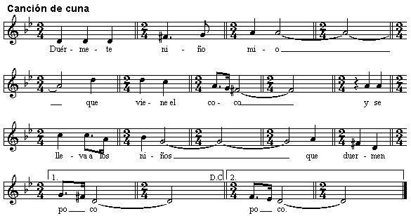



CANCIÓN DE CUNA  Tradicional de Murcia  Duérmete niño mío  que viene el coco  y se lleva a los niños  que duermen poco | LULLABY  Traditional of Murcia  Sleep my little baby  The bogeyman is coming  And takes away the children  That sleep very little

BIRTH SONGS

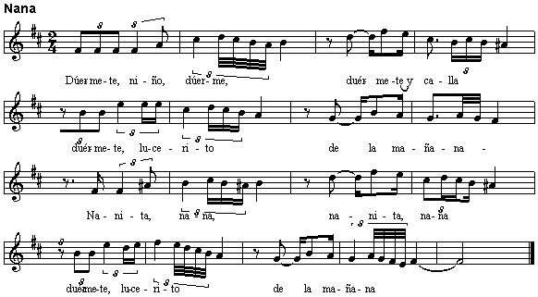

NANA  Tradicional de Andalucía  Duérmete, niño, duérme,  duérmete y calla,  duérmete, lucerito de la mañana.  Nanita, nana, nanita, nana  duérmete, lucerito de la mañana. | LULLABY  Traditional of Andalucia  Sleep, child, sleep,  Sleep and be quiet,  Sleep, first light of the morning.  Lull-lullaby, lull-lullaby  Sleep, first light of the morning.

MARRIAGE SONGS

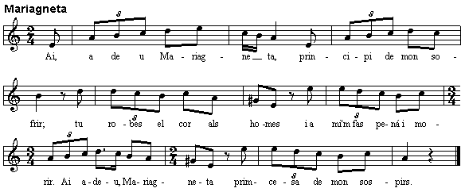

MARIAGNETA  (Tradicional Catalunya)  Ai, adeu Mariagneta,  principi de mon sofrir;  tu robes el cor als homes  i a mi em fas pena i morir.  Ai adeu, Mariagneta  primcesa de mon sospirs.  Ton amant és a la porta,  que no espera si no el si;  no desconsolis tons pares  per a consolar-me a mi,  que jo ja me'n fare frare  de l'ordre del caputxí.  Quan siguis casadeta  ja m'ho enviaràs a dir.  M'enviaràs una lletra  com et va amb el teu marit;  jo t'enviaré una altra  com em va en el monestir.  Si tens una criatura  deixa'm-li ser padrí;  si no m'ha estimat la mare  que al menys m'estimi el fill. | Ai, adeu Mariagneta,  princesa dels meus sospirs.  Un dia dient la missa  ja la carta en va venir;  escuses de besar a terra  ja la carta va cullir,  la missa mai s'acabava  per a poder-la llegir.  Al sobre escrit de la carta  ja n'arrenca un gran sospir.  Agneta de més entranyes  si et podés tenir aquí  amb un rato de conversa  no em sabria greu morir.  Quant la missa es acabada  la lletra corre a llegir  tot just n'era a mig llegir-la  n'arrencava un gran sospir.  Ai, adeu Mariagneta,  que jo m'en sento morir. | MARIAGNETA  (Traditional of Catalunya)  Ah, goodbye Mariagneta,  The beginning of my suffering;  You steal the hearts of men  And you make me suffer and die.  Ah, goodbye Mariagneta  Princess of my sighs.  Your lover is at the door,  Waiting only for the word yes;  Don’t let your parents down  In order to comfort me,  And I will become a Friar  Of the Order of the Capuchin.  When you get married  You’ll send me a message  Letting me know how it goes with your husband.  I´ll send you another one  Telling you how things are going in the monastry  If you´ve got a baby,  I would like to be the godfather;  If the mother hasn’t loved me | At least the son will do.  Ah, goodbye Mariagneta,  Princess of my sighs.  One day while saying Mass  A letter came;  I will go to kiss the ground,  But pick up the letter instead  So as to read it.  On seeing the envelope  I let out a great sigh.  Agneta, how I wish you were here  With a moment of conversation  I wouldn’t mind dying.  When the Mass is over  He runs to read the letter  And when he was in the middle of it  He let out a great sigh.  Ah, goodbye Mariagneta  I feel like I’m dying.

MARRIAGE SONGS

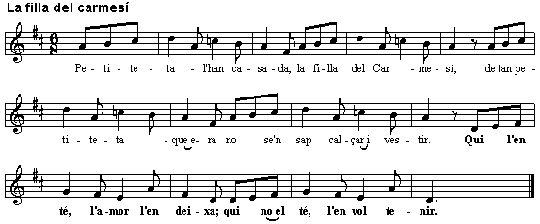

LA FILLA DE CARMESÍ  (Tradicional de Catalunya)  Petiteta l'han casada,  la filla del Carmesí;  de tan petiteta que era  no se'n sap calçar i vestir.  Qui l'en té, l'amor, l'en deixa;  qui no el té, l'en vol tenir.  Lo comte la n'ha deixada,  de set anys no hi vol dormir;  l'ha deixada a ca sa mare  perquè no l'en sap servir.  Qui l'en té...  I se n'ha anat a la guerra  sols per deixar-la engrandir;  des del dia de les noces  set anys trigarà a venir.  Qui l'en té...  Al cap d'aquesta setena  son marit torna a ser aquí.  Ja en pega un truc a la porta:  - Carmesina, baixa a obrir. -  Qui l'en té... | Pregunta a la seva mare  que lo truc ne va sentir:  - A on és la Carmesina,  mare, que no em baixa a obrir?  Qui l'en té...  - Com ne baixarà la trista,  si no és en tot per ací?  El rei moro se l'ha enduta,  disset llegües lluny d'ací.  Qui l'en té...  -Mare, baixeu-me la capa,  la capa de bombosí;  cercaré la Carmesina  ni que m'haja de morir.  Qui l'en té... | THE DAUGHTER OF CARMESI  (Traditional of Catalunya)  They arranged her a marriage,  The young daughter of Carmesi;  She was so young that she didn’t know how to tie her shoes or dress herself.  The one who has love, can leave it:  The one who doesn’t, would like it.  The Count has abandoned her,  She´s only seven and doesn´t want to sleep;  He´s left her with her mother  Because she doesn´t know how to serve him.  The one who has love…  And he has gone to the war  Just to let her grow up;  From the day of the marriage  He leaves for seven years.  The one who has love…  After these seven years  Her husband comes back.  He knocks on the door:  ´Carmesina, come down to open the door´.  The one who has love… | She asks her mother  When she hears the knocking:  ´Where is Carmesina, mother, who doesn´t come to open the door?´  The one who has love…  ´How is this sad girl going to answer the door, when she is not here?´  The Moorish King has travelled  Seventeen leagues to be here.  The one who has love…  ´Mother, bring me my cloak,  The cotton cloak;  I’m going to look for Carmesina  Although I might die.  The one who loves…

DEATH SONGS

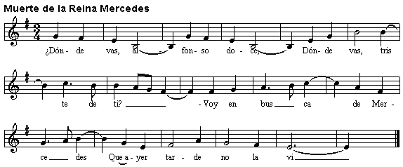

MUERTE DE LA REINA MERCEDES  (Tradicional de La Rioja)  - ¿Dónde vas Alfonso doce, donde vas, triste de tí?  - Voy en busca de Mercedes, que hace tiempo no la ví.  - Si Mercedes ya se ha muerto, el entierro yo lo ví;  las señas de cómo iba yo te las puedo decir:  Cuatro duques la llevaban por las calles de Madrid;  su carita era de cera, sus manitas de marfil.  Sandalias bordadas de oro llevaba en sus lindos pies,  que se las bordó la infanta la infanta doña Isabel  El manto que la envolvía era rico terciopelo  y en letras de oro decía: "Ha muerto cara de cielo".  Los caballos de palacio ya no quieren pasear  porque se ha muerto y luto quieren llevar.  - Al entrar en mi palacio una sombra negra ví:  cuanto más me retiraba más se venía hacia mí.  - No temas, Alfonso doce, ni te asustes, ¡Ay de mí!  que soy tu esposa Mercedes que me vengo a despedir. | THE DEATH OF QUEEN MERCEDES  (Traditional of La Rioja)  - Where are you going Alfonso XII, where are you going, so sad?  - I’m looking for Mercedes, who I haven’t seen for a while.  - Yes Mercedes has already died, I saw the funeral;  The signs of what she was wearing I can tell you:  Four Dukes carried her through the streets of Madrid;  Her little face was like wax, her little hands like ivory.  Sandals embroided with gold on her lovely feet  Which were embroided by the infant doña Isabel  The shroud which surrounded her was rich velvet  And in golden letters it said: ´A face of Heaven has died´.  The horses in the palace don’t want to walk now  Because she has died and they want to wear mourning clothes.  - On entering my palace a black shadow I saw:  The more I went away the closer it got to me.  - Don’t be afraid, Alfonso XII, don’t panic, woe is me!  I am your wife Mercedes who comes to say goodbye.

DEATH SONGS

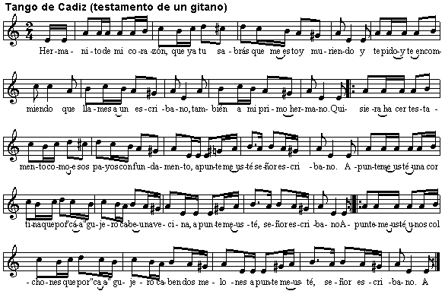

TANGO DE CADIZ (Testamento de un de gitano)  Hermanito de mi corazón,  que ya tu sabrás que estoy muriendo  y te pido y te encomiendo  que llames a un escribano,  también a mi primo hermano.  Quisiera hacer testamento  como esos payos con fundamento,  apunteme usté señor escribano.  Apunteme usté una cortina  que por "cá" agujero cabe una vecina,  apunteme usté señor escribano.  Apunteme usté unos colchones  que por "ca" agujero caben dos melones  apunteme usté señor escribano.  Apunteme usté una escopeta  que no tiene llave cañon ni baqueta  apunteme usté, señor escribano.  apunteme usté un cuadro "rompío"  que ya ni sabe el santo que ha "sío"  apunteme usté, señor escribano. | THE TANGO OF CADIZ (The will of a gypsy)  Little brother of my heart,  You will know that I am dying  And I ask you and I beg you,  To call the clerk,  And also the son of my uncle.  I would like to make my will  Like a non-gypsy person,  Write it down Mr clerk.  Write down a curtain  Where every hole is a neighbour,  Write it down Mr clerk.  Write down some mattresses  Where every hole has space for two melons  Write it down Mr clerk.  Write down a gun  That doesn’t have a safety catch nor a ramrod  Write it down Mr clerk.  Write down a broken picture  Which doesn’t remember the Saint it was  Write it down Mr clerk.

TURKEY SONGS
TURKISH LULLABABIES

UYUSUN DA BÜYÜSÜN | SLEEP AND GROW UP
Uyusun da büyüsün ninni  Tıpış tıpış yürüsün ninni  Eee.. Eee.. Eee.. Eee..  Uyu yavrum ninni  Dandini dandini danalı bebek  Elleri kolları kınalı bebek  Eee.. Eee.. Eee.. Eee..  Uyu yavrum ninni | Sleep and grow up ninni ninni (sleep well)  Walk beautifully, ninni ninni  Eee.. Eee.. Eee.. Eee..  Sleep my child ninni  Dandini dandini the baby with small cow  The baby with henna in his hands and arms  Eee.. Eee.. Eee.. Eee..  Sleep my child ninni

BEBEĞİN BEŞİĞİ ÇAMDAN | A PINE CRADLE OF A BABY
Bebeğin beşiği çamdan  Yuvarlandı düştü damdan  Beybabası gelir şamdan  Nenni nenni, nenni nenni  Nenni nenni, nenni bebek oy  Bebeğin beşiği bakır  Yerinden kalkmıyor ağır  Ben sallarım takır takır  Nenni nenni, nenni nenni  Nenni nenni, nenni bebek oy | The baby’s cradle is made from pine  He rolled and fell down from roof  His grandfather comes from Damascus  Nenni nenni, nenni nenni  Nenni nenni, nenni my baby oy  The baby’s cradle is copper  It is too heavy to move  I move it loudly  Nenni nenni, nenni nenni  Nenni nenni, nenni my baby oy

DEATH SONGS
YEMEN TÜRKÜSÜ | YEMEN SONG
Havada bulut yok bu ne dumandır,  Mahlede ölü yok bu ne figandır.  Şu yemen elleri ne yamandır.  Ah o yemendir gülü çemendir.  Giden gelmiyor acep nedendir  Burası Huş’tur yolu yokuştur  Giden gelmiyor acep ne iştir?  Kışlanın önünde redif sesi var  Bakın çantasında acep nesi var  Bir çift kundurayla bir de fesi var | There is no cloud in the sky,  what a smoke  There is no die in the neighbourhood  what a fowl,  There are strange places what  Ooo Here is Yemen, rose is grass  Somebody is going and doesn’t come , Why somebody is going.  Here is Muş and Muş’s road is gradiant,  Somebody is going and don’t come back  In front of the barracks a voice of soldier  Look his bag what he has  A pair of boat and fez he has

HASTANE ÖNÜNDE İNCİR AGACI | A FIG TREE IN FRONT OF THE HOSPITAL
Hastane önünde incir ağacı  Doktor bulamadı bana ilacı  Baştabib geliyor zehirden acı  Garip kaldım yüreğim dert oldu  Mezarımı kazın bayıra düze  Yönünü çevirin sıladan yöne  Benden selam söyle sevdiğime  Başını koysun karalar bağlasın  Gurbet elde kaldım diye ağlasın. | A fig tree in front of the hospital  Doctor doesn’t find me any medicine.  Doctor is coming but he is bitter than posion.  It is a grief for me to be in a needy mood.  Strange people’s native country worries me  Excuate my tomb in a plain place.  Turn the direction to my hometown,  Say goodbye to my lover  Put her head and mourning  She cries that I’m out of my country.

WEDDING SONGS

EVLERININ ÖNÜ BOYALI DIREK | THE HOUSE WHICH HAS GOT POLE WITH PAINT
Evlerinin önü boyalı direk  Yerden yere vurdun sen beni felek  Her acıya dayanamaz bu yürek  Ölürümde ayrılmam yar senden  Evlerinde lambaları yanıyor  Göz göz olmuş ciğerlerim kanıyor.  Beni gören deli olmuş sanıyor  Ölürümde ayrılmam yar senden.  Amam bir bahçeye giremezsen  Durup seyran eyleme  Aman bir binayı yapamazsan  Yıkıp viran eyleme  Aman bir güzeli sevip de alamazsan  İsmini aleme rüsva eyleme | The house which has got pole with paint  Destiny,you hit me from down to down  My heart doesn’t suffer all these worries  I die but I don’t leave from you.  Her house’s light is open  My lungs fire in every parts  Someone thinks I’m a mad person  I die but I don’t leave from you.  If you don’t enter a garden  Don’t look  If you don’t build  Don’t pull down and don’t ruined  If you love somebody and don’t married  Don’t say your name!

